CHEMICAL ENGINEERING TRANSACTIONS  VOL. 76, 2019 | A publication of
The Italian Association
of Chemical Engineering
Online at www.cetjournal.it
Guest Editors: Sauro Pierucci, Jiří Jaromír Klemeš, Laura Piazza
Copyright © 2019, AIDIC Servizi S.r.l.
ISBN 978-88-95608-73-0; ISSN 2283-9216

A Bayesian Belief Network for Local Air Quality Forecasting
Tomaso Vairo^{ac}*, Mario Leccaª, Elisabetta Trovatoreª, Andrea P. Reverberi^{b}, Bruno Fabiano^{c}
ª ARPAL, via Bombrini 8 - 16149 Genoa Italy
^{b} DCCI - Chemistry and Industrial Chemistry Dept., Genoa University, via Dodecaneso 31 - 16145 Genoa, Italy
^{c} DICCA - Civil, Chemical and Environmental Engineering Dept. – Genoa University, via Opera Pia 15 - 16145 Genoa, Italy
*tomaso.vairo@arpal.gov.il
This study is focused on the development of a Bayesian network for air quality assessment and aims at offering a pragmatic and scientifically credible approach to modelling complex systems where substantial uncertainties exist. In particular, the main object is the prediction of the occurrence of suitable conditions for the stagnation of pollutants in a given area. The analytical modeling of the network provides a set of independent nodes, represented by the outputs of a forecasting meteorological LAM model, from which descend the conditions for the stagnation of pollutants in different areas of the city (through measurements of the heuristic pollutant from monitoring stations) and finally the global conditions. The urban area of Genoa (Italy) was selected in order to test the actual capability of the model prototype. Network training was performed by means of historical data resulting from significant statistical series of the past years by the air quality-monitoring network. The system used for data assimilation, construction and network learning is completely based on an open source statistical processing software.
  - Introduction
Atmospheric pollution in urban areas has become one of the key environmental issues to be faced, given its serious adverse effects on human health. Two main modelling approaches can be outlined: the former is based on numerical modelling by simulating atmospheric dispersion and transport starting from emission source characterization. The latter is based on advanced statistical models including artificial intelligence, machine learning technologies and soft computing techniques (e.g. Alimissis et al., 2018). As widely acknowledged, the quantification of uncertainty of modelling results and the optimal selection of the atmospheric dispersion model relies on an accurate evaluation on how model uncertainty in model inputs affects the outputs (Vairo et al. 2014). In case of complex geometries, such as urban areas additional limitations arise, so that, for example, the numerical or analytical resolution of the relevant inverse problem starting from field experimental data back to the pollution source requires a proper regularization technique (e.g. Reverberi et al., 2013). The choice of appropriate level of detail and complexity is based on the purpose and application area the model is to be used (Baklanov et al., 2008). The focus of this work is to evaluate the results that the Bayesian networks could achieve in such a context with the goal of performing a reliable forecasting of critical air quality conditions, connected to the stagnation of pollutants. We have tested several different configurations in order to investigate the relevance of different factors such as the topology of the net, availability and consistency of historical data, evidence provided and so on. Bayesian networks automatically capture probabilistic information from data using directed acyclic graphs and factorized probability functions. The graph intuitively represents the relevant spatial dependencies and the resulting factorized probability function leads to efficient inference algorithms for updating probabilities when new evidence is available. The remainder of this paper firstly outlines the development of Bayesian networks using two approaches, i.e. self-construction from experimental air pollution database and critical BN development by application of expert knowledge, using both discrete and continuous (Gaussian) nodes. Subsequently, the network is tested with different learning algorithms (hill climbing, Grow-Shrink, Incremental Association, Tabu search), Predictions and forecasting methods, including their estimation in an iterative Markov chain Monte Carlo (MCMC) computation setup. The results of the network accuracy based on the scores are finally represented and critically discussed in the perspective of providing an efficient and robust option for air quality forecasting at the local scale.
  - Analytical modelling and Bayesian Reasoning
Analytical models are mathematical models that have a closed-form solution, i.e. the solution to the equations used to describe changes in a system can be expressed by a mathematical analytical function (e.g. Aguilera et al., 2011). The purpose of the analysis is to understand something about the nature of the real world by studying the observed data in relation to their context. Fig. 1 depicts a schematic view of analytical modelling: x-axis reflects the purpose of modelling, ranging from association/correlation to causality. Y- axis represents the source of the model conceptually ranging from theory to data. The theory (parametric) is labelled with Human Intelligence, suggesting the origin. At the opposite end of the y-axis, Data are commonly associated with Machine Learning and Artificial Intelligence.

Figure 1: Map of analytical modelling.
The Bayesian network, also known as the reliability network, is an extension of the Bayesian method and is one of the most effective theoretical approaches for uncertain knowledge representation and reasoning, which allows analysing the phenomena accepting evidence for any node and therefore using the Bayes theorem to calculate the a posteriori probabilities of the events. As for the horizontal division between theory and data on the model, a dynamic network can derive from expert knowledge, which is from the theory (Human Learning), or it can be predictive, i.e. the machine learns from the data (Machine Learning). In this respect, dynamic networks can use the entire spectrum as the source of the model. As amply discussed in different contexts (Pasman and Rogers, 2013), the basic concept of the bayesian approach regards the conditional probability that indicates the probability of the event A given the event B. The Bayesian networks allow us to represent the joint probability distribution for the environment of interest and their name descends from the Bayes theorem that is the fundamental mathematical tool in order to update the values of the networks when they are subjected to some new evidences:

$P\left(A | B\right)=P\left(A\right)\frac{P\left(B|A\right)}{P\left(B\right)}$ (1)

where:
P(A) is the prior probability (or “unconditional” or “marginal” probability) of A.
P(A|B) is the conditional (posterior) probability of A, given B. P(B|A) is the conditional probability (likelihood) of B given A. P(B) is the prior or marginal probability of B, and acts as a normalizing constant.
$\frac{P\left(B|A\right)}{P\left(B\right)}$ is the Bayes factor or likelihood ratio.
The Bayesian approach is based upon the probability assigned to an event as a consequence of the current knowledge (inference process). A Bayesian network provides a complete description of the application domain in the form of a conditional probability distribution and is a directed acyclic graph in which each link is directed from a parent node to its child. Each node represents a variable of the domain and the links represent causal dependencies among the variables. The possible values of each variable are divided into some intervals (of a given width), or are considered in a Gaussian distribution. Evidence is called the a-priori information about the degree of certainty assigned to the possible states of a variable. Each variable without parents is characterized by an a-priori probability table, while each variable A with some parents B₁,...,B_{n} has a conditional probability table that expresses the joint probability. A generic element of the conditional probability table is the probability that occurs as a combination of two specific values of the variables. More in general, we can express it in the form: P(X₁ = x₁ | ... | X_{n} = x_{n}). Following expression applies:

$P\left(x_{1},…,x_{n}\right)=\prod_{i=1}^{n}{P}\left(x_{i}|Parents\left(X_{i}\right)\right)$ (2)

The construction of a Bayesian network can be performed according to the following phases:
- A set of variables Ai (i=1, ..., n) is chosen to describe the system;
- To each variable Ai is associated a node of the network;
- The set Parents(Ai) of the nodes parents of Ai is fixed;
- The table of the conditioned probabilities for Ai is defined by the learning of a set of cases.
  - The Bayesian model
The here defined Bayesian Beliefs Network for Air Quality (BBNAQ) system relies on following data acquisition and elaboration:
- Forecasting data of temperature T, wind W, humidity H and rain R, from MOLOCH meteorological model (2013-2016) as described below.
- PM10 concentration data (2013-2016) from three stations in the urban monitoring network of Genova (S1, S2, S3), as daily average concentration.
- The data are inserted in an analytical model which is developed ad-hoc starting from the the R statistical processing approach (Scutari, 2010).
The meteorological data were extracted from the archive of the operational meteorological model MOLOCH, which provides two-days high resolution forecast. It is a limited area model, which integrates the non-hydrostatic, fully compressible equations for the atmosphere, with 50 atmospheric levels and 7 soil levels, with a resolution of 0.02°, corresponding roughly to 2 km. The forecasting data were extracted from the previous day run and consist on the following parameters: wind intensity at 10 meters, temperature at 2 meters, relative humidity at 2 meters and total precipitation cumulated in the previous 3 hours. The steps of the analytical modeling were:
- data extraction from MOLOCH, processing and labeling suitable for the construction of the network;
- collection of concentration data from the control units, processing and labeling suitable for the construction of the network;
- preliminary statistical analysis;
- development of the network with different learning algorithms (hill climbing, Grow-Shrink, Incremental Association, Taboo search);
- validation of the consistency of the network
Learning is based on T, W, H, R, and S1, S2, S3 historical data recorded starting from the data 2013-2016. A two-stage modelling approach was adopted: the Bayesian network was manually established by expert knowledge, and then the previously obtained Bayesian network model is corrected by learning the data sets suitable to perform an automatic construction of BBN.
    - BBN from expert knowledge
In this case, an empty DAG (Direct Acyclic Graph), i.e. an empty network with dependencies decided by theory and knowledge was created. Subsequently, the fitting between the dataset and the DAG was performed (i.e. in the “T” node, all the Temperature data are fitted) and the same for other nodes, as shown in Fig. 2). As discussed in the following, a subset of available data was subsequently utilized for validation of the predictive ability of the scheme.

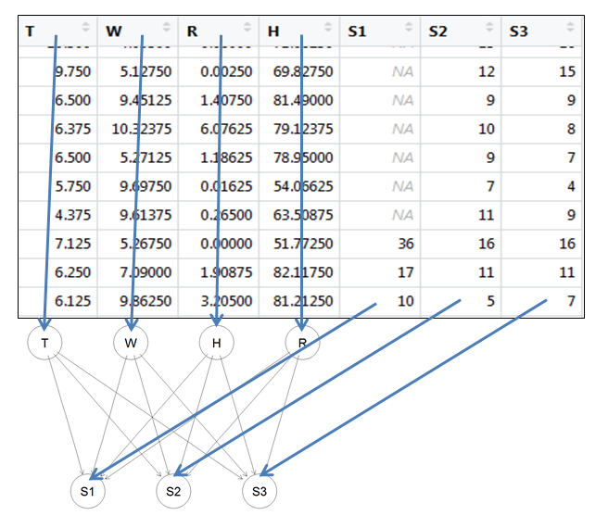
R
H
Figure 2: BBN from expert knowledge. Each node contains the proper value derived from the whole dataset.

Two methods were then tested: the first, dividing the data, in each node, in 5 discrete intervals (discrete value network depicted in Fig. 3a), the second, leaving the data according to a continuous distribution (Gaussian network – Fig. 3b).
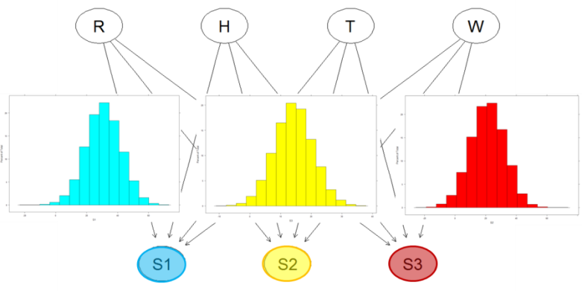
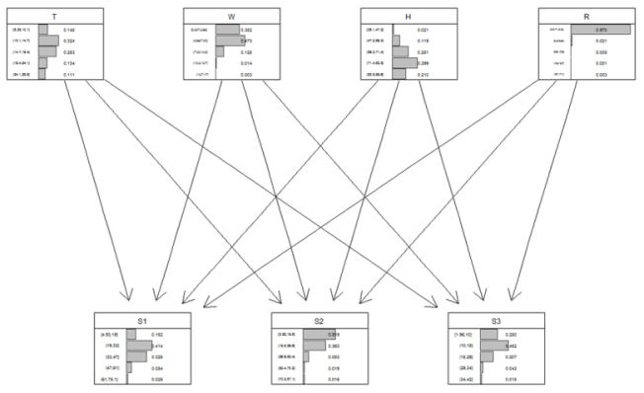
(a)
(b)

Figure 3: (a) Discrete network from expert knowledge: in each node, the prior probabilities are reported, where the data in the dataset are divided into 5 discrete intervals. (b) Gaussian Network from expert knowledge: in each node, the frequency distribution is reported.
    - Automatically built BBN
In this case, the building of the network with continuous values (Gaussian Bayesian network) is directly derived from the whole data set. The structure of the network derives from the data analytics (clusters analysis and correlations). As depicted in Fig. 4, the automatically built structure evidences analytical dependencies between the nodes that are often not intuitive, but that, with the use and validation of the model, are proved statistically significant. A noteworthy example in the case-study is the attainment of the independence of station S3 from the parameter “wind”, connected to the actual localization of this monitoring station in a sheltered position, preventing wind action. This evidence was correctly captured by the automatic construction of the network but from the “expert knowledge” analysis, based only on raw data acquisition.

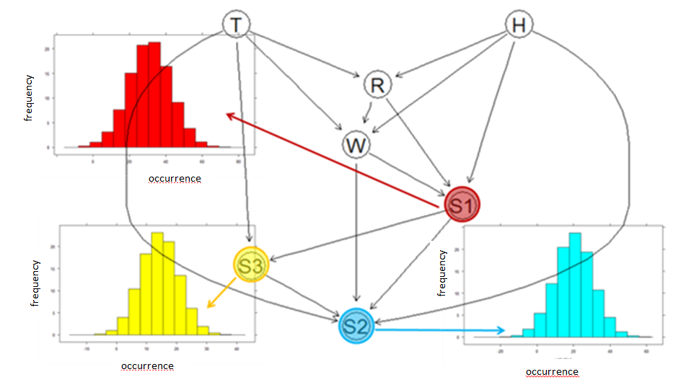
Figure 4: Gaussian network obtained from data.
  - Results
Fig. 5 depicts the results obtained by the network with continuous values (Gaussian Bayesian network) – from expert knowledge, whose distribution parameters are summarized in Table 1. The response is obtained using the MCMC (Markov Chain Monte-Carlo) sampling method.
Table 1: Gaussian BBN from expert knowledge - distribution parameters.
Min. | 1st Quartile | Median | Mean | 3rd Quartile | Max.
0.2792 | 0.2890 | 0.2926 | 0.2927 | 0.2955 | 0.3125

Table 2 and Figs. 6 a-b provides comparison between the prediction ability of BBN from expert knowledge, and BBN from data analytics. The last approach allows a free implementation of structure learning algorithms along with the conditional independence tests and network scores (Scutari, 2010). The mean performance of each scheme is examined using a set of difference and correlation measures (i.e. Mean Error, Root Mean Square Error, Mean Absolute Error, Mean Percentage Error and Mean Absolute Percentage Error).

Table 2: Gaussian BBN observed vs. predicted - distribution parameters obtained from expert knowledge and data analytics.
 | ME | RMSE | MAE | MPE | MAPE
Expert knowledge | 2.24514e-14 | 10.45438 | 8.219454 | -14.71306 | 33.29295
Data analytics | 0.0214116 | 7.679559 | 5.761562 | - 8.654668 | 23.18986

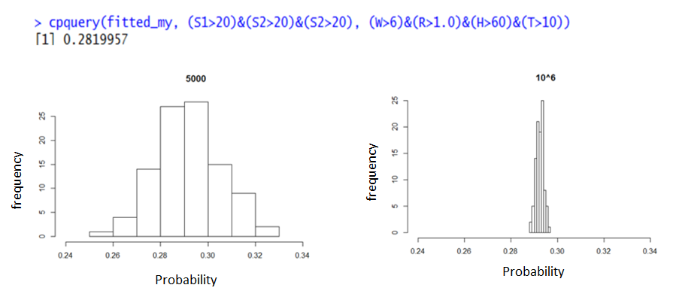
Figure 5: Gaussian BBN from expert knowledge: the accuracy of the result depends upon the actual number of iteration in MCMC.
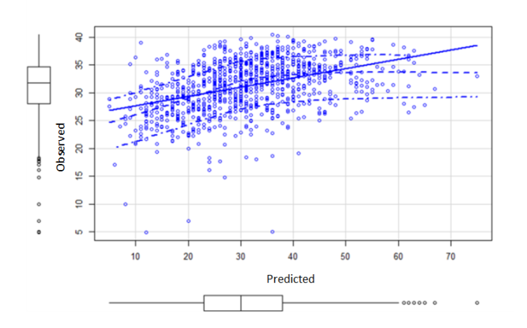
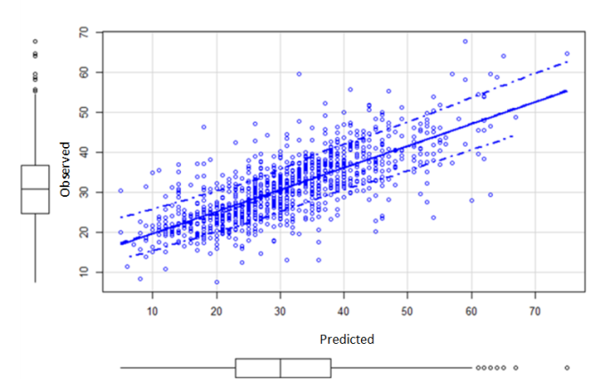

(a)
(b)

Figure 6 a-b: (a) Gaussian BBN from expert knowledge. (b) Gaussian BBN from data analytics. Observed vs. predicted
As shown in Figs. 6(a) and 6(b) showing the comparison of the model predictions and the observed values the best configuration among the tested modelling approaches is given by the automatically built from data analytics Gaussian network. As clearly indicated also by the statistical parameters summarized in Table 2, the BBN from data analytics shows a better prediction ability. The Mean Absolute Error (MAE), represents the sum of two components: Quantity Disagreement and Allocation Disagreement. Even if the BBN from expert knowledge evidences a better Quantity disagreement (ME), the BBN from data analytics has a far better allocation disagreement, which globally allows an improvement of all the distribution parameters utilized, which from an applicative viewpoint translates into a better predictive ability.
  - Conclusions
The proposed systems are currently in (experimental) use at the meteo-hydrological centre of the Liguria region, in order to daily issue an air quality bulletin. From a methodological point of view, the most important results obtained from the tested network models can be summarized in the following points:
- the Gaussian network provides better forecasts of the discrete network;
- the network built automatically by the data provides better results of the network built by expert knowledge
- the optimal configuration in the given urban context corresponds to the self-built Gaussian network
Future developments of the system currently under investigation include the validation of the current network based on the scores and the implementation of a novel with incoming PM10 concentration data from the previous day. Additionally we are currently performing a cross check comparison obtained by a non-Bayesian neural network (i.e., by Error back-propagation).
Acknowledgments
The authors would like to acknowledge all the staff of the meteo-hydrological centre of environmental protection agency of Liguria (ARPAL – CFMI). The authors also would like to thank Prof. Marco Scutari, of Oxford University, UK for kindly providing expertise on bnlearn package.
References
Alimissis A., Philippopoulos K., Tzanis C.G., Deligiorgi D., 2018, Spetial estimation of urban air pollution with the use of artificial neural network models, Atmospheric Environment 191, 205-213.
Aguilera P.A., Fernández A., Fernández R., Rumí R., Salmerón, A., 2011. Bayesian networks in environmental modelling. Environmental Modelling & Software 26, 1375-1774.
Baklanov, A., Korsholm, U., Mahura, A., Petersen, C., and Gross, A., 2008. ENVIRO-HIRLAM: on-line coupled modelling of urban meteorology and air pollution, Adv. Sci. Res., 2, 41-46
Pasman H.J, Rogers W.J., 2013, Bayesian networks make LOPA more effective, QRA more transparent and flexible, and thus safety more definable! Journal of Loss Prevention in the Process Industries, 26, 434-442.
Reverberi A.P., Fabiano B., Dovì V.G., 2013, Use of inverse modelling techniques for the estimation of heat transfer coefficients to fluids in cylindrical conduits. Int. Commun. in Heat and Mass Transfer 42, 25-31.
Scutari M., 2010. Learning Bayesian Networks with the bnlearn R Package. Journal of Statistical Software 35(3), 1-22.
Vairo T., Currò F., Scarselli, S., Fabiano B., 2014, Atmospheric emissions from a fossil fuel power station: Dispersion models comparison. Chemical Engineering Transactions 36, 295-300.

